UAT Execution & Report Submission
Team ID | Date | Project | Maximum Marks
SWTID-2026-1237 | 01/10/2026 | EduGenie | 4 Marks

1.Purpose of Document
The purpose of this document is to briefly explain the test coverage and open issues of the EduGenie project at the time of the release to User Acceptance Testing (UAT).
2.Defect Analysis
This report shows the number of resolved or closed bugs at each severity level , and how they were resolved.
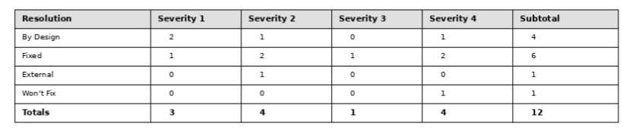
3.Test Case Analysis
This report shows the number of test cases that have passed, failed, and untested
